**Lab#1(a) Creating a registration Page with HTML 5 Validation**

|  |  |  |
| --- | --- | --- |
| **TAGS USED** | **ATTRIBUTES USED** | **DESCRIPTION** |
| <HTML> | -- | Write the description of HTML tags and attributes |
| <HEAD> | -- |  |
| <TITLE> | -- |  |
| <BODY> | BGCOLOR,TEXT, BACKGROUND |  |
| <H1>,<H2>,<H3>, <H4>,<H5>,<H6> | ALIGN |  |
| <FONT> | FACE,SIZE,COLOR |  |
| <P> (Paragraph) | -- |  |
| <U> (Underline) | -- |  |
| <HR> (Horizontal Rules) | WIDTH,COLOR,ALIGN |  |
| <BR> (Break Line) | -- |  |

**Final Outcome: [Font Cambria, size 14 bold]**

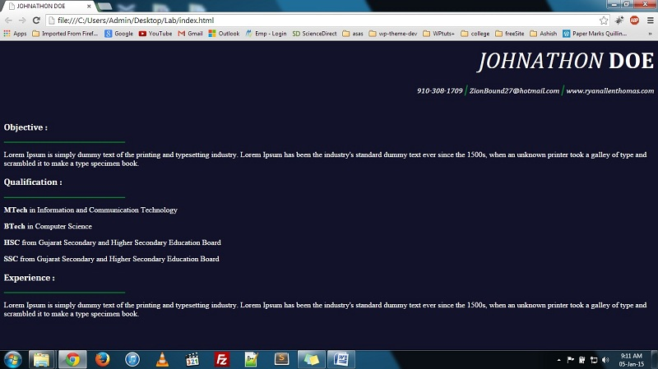

(Basic HTML, Hyperlink and Commenting code)[Font Cambria size 12]

**Code Snippet:**

<html>

<head>

<title>test html</title>

</head>  
<body>

<h1>My First Heading</h1>  
<p>My first paragraph.</p>

</body>

</html>

**Note:**

**No plagiarism will be entertained. Such work will be rejected. Students are suggested to perform lab sessions on their own.**

**Practical are expected to be submitted within given deadline by faculty.**

**You need to follow this format with all its settings.**

* **Header [only need to change Lab title and Department name]**
* **Footer [Author name [enr. no.] and page number]**
* **Fonts and Font sizes**